Working with Write N Cite 4

Write-N-Cite 4 looks a little different than earlier versions of Write-N-Cite. On Word for Mac, it's a small, floating toolbar. On Word for Windows, it's a ribbon.
If you are using Word 2016 on Mac, you will need to install RefWorks Citation Manager (RCM) as per the instructions at the end of this handout.
Write-N-Cite 4 toolbar for Mac
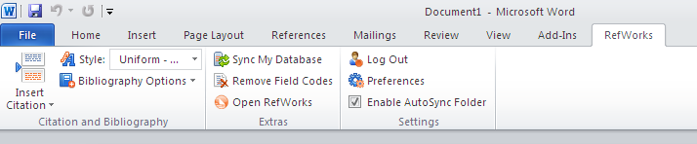
Write-N-Cite 4 ribbon for Windows
Some other changes include:
- No more curly bracket placeholders! Your paper will be formatted as you work, but you can still change the citation style at any point in your writing process.
- You can easily edit citations as you insert them to hide or add information as you need.
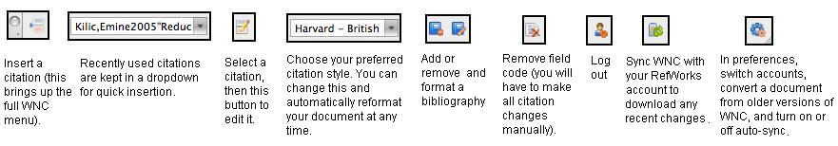
When you select Insert or Edit a citation, a window will appear with many more options:
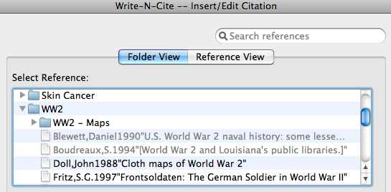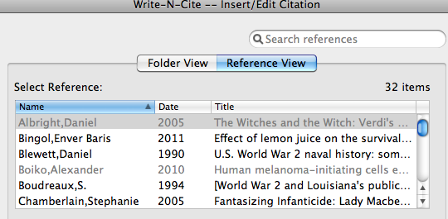
- View reference by folder, or sorted by author, date, or article title
- Insert several citations at a time by simply double clicking each reference
- References that have already been included will be greyed out
- Search all references from the top right-hand bar

Write-N-Cite will automatically insert the appropriate fields for your chosen style, but you can override these settings by editing a reference:
- Hide the year or author if you've already mentioned them in-text
- Suppress the page numbers, or alter them from the original citation
- Include a citation as a footnote, or keep it out of the text all together but include it in your bibliography
- Add additional information:
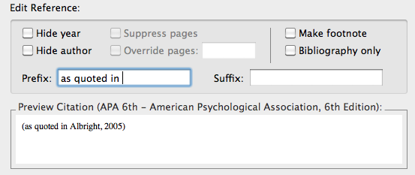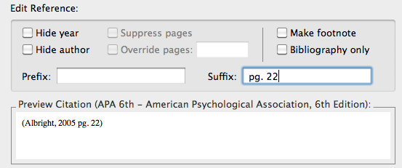
- Fields will be greyed out when not applicable to your chosen style.
- All changes will appear right away in the Preview Citation window.

If your chosen style has a rule about which order citations should appear in, they will be placed in that order. If you need to change the order, tick "Override default ordering" at the bottom. You can then use the arrows to re-order your citations.
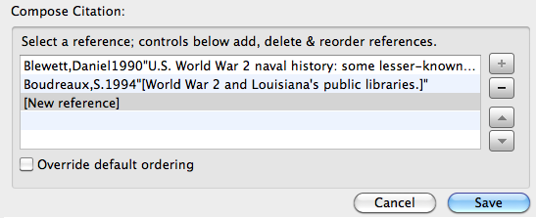

Inserting page numbers
Page numbers should be inserted using the Suffix box in the Insert/Edit Citation window:
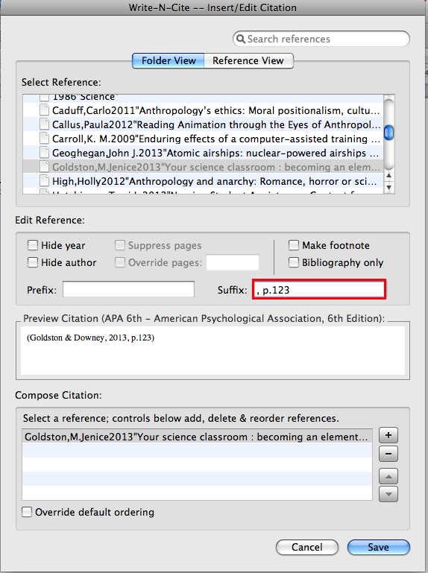
If you've already created the citation, you can access the Insert/Edit Citation window by double-clicking on the in-text citation (on Windows) or by clicking the Edit Citation icon on the toolbar (on a Mac).

RefWorks Citation Manager (RCM) for Word 2016 on Mac:
RCM is the new RefWorks plug-in for Word 2016 on Mac and supports Legacy RefWorks (currently used by UBC). For information and the link to add this plug-in, see the Microsoft Office Store http://bit.ly/2dqzwVG.
To install the plug-in, see the installation guide http://bit.ly/2dM8YBc.

