Useful View Tricks in Word

Outline View
- Use the buttons on the far lower left of the window to toggle between view options
  - Far left is draft view, second from the left is outline view, fourth from the left is print view

Navigation Pane
To make the sidebar Navigation pane appear, go to the View menu> Sidebar and select from the options. “Document map” allows you to navigate using section headings. Once you make the sidebar visible, you can switch between different viewing options using the four buttons at top of the pane.

Showing Hidden Codes
To reveal codes which are usually hidden – such as paragraph markers, tabs, page breaks, and section breaks – click the ¶ button on the toolbar at the top of the window (This is the “Standard” Toolbar. If you have changed your view options, this toolbar may not be visible.). You can also go to the View menu and select “Markup”

Page Layout and Numbering

How to change page numbers
Go to the Insert menu> Page Numbers to open the page numbers window. Click the “Format” button, and change the number format using the drop down menu at the top of the window

To change your page numbers after a section break
Follow the instructions above to open the “Page Number Format” window. Click the “Continue from previous section” button if you want your numbers to continue consecutively. Click the “Start at” button if you wish to re-start your numbers, and use the drop-down menu to select which page number to start with.

How to put one page in landscape orientation
- Insert section breaks before and after the section you wish to put in landscape. On the Layout Tab, click on the Break button on the Page Setup pane, and select Section Breaks > Next page. You can also go to Insert> Break> Section Break (Next page). THEN,
- Go to the Layout Tab. Click on the Orientation button on the Page Setup pane and select “Landscape”.
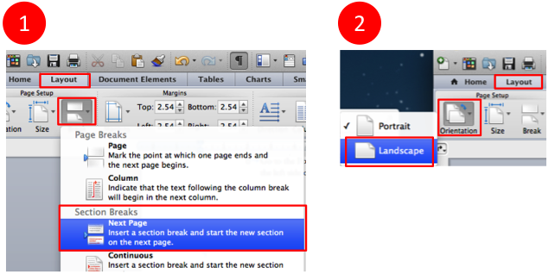

Chapters and Sections

How to apply heading styles
- Go to the Home tab and select the style you wish to use from the Styles pane

How to modify heading styles
  - Go to the Home tab, right click on the style you wish to modify in the styles pane
  - Go to the Format menu > Styles. Select the style you wish to modify from the menu bar on the left side of the window, and click the “Modify” button

Notes on styles
- Only text which you’ve applied a Heading style to (i.e., one of Heading 1 through Heading 9) will appear in your Table of Contents.
- If there is material in your Table of Contents which is not supposed to be in your Table of Contents (e.g., body text below a heading), make sure that that material is in “Normal” style rather than one of the Heading styles.

Table of Contents

How to create a Table of Contents
- Apply heading styles as necessary, go to the Insert menu > Index and Tables, go to the Table of Contents tab (or go to Document Elements tab > Options ), and select the TOC style you wish to use from the Table of Contents pane
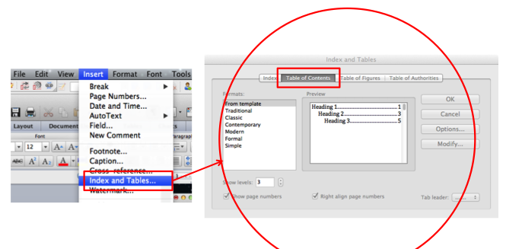

How to update a Table of Contents
- Go to the Document Elements tab, and click the “Update” button on the Table of Contents pane

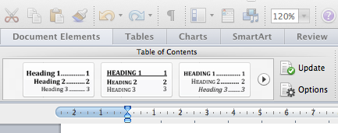

You’ll be given two options: “Update page numbers only” or “Update entire table.” Updating the entire table is more comprehensive, but it can take several minutes in a long document, so you may prefer to only update the page numbers if the chapter and section headings have not changed

Tables, Figures and Other Objects

How to make the heading row of a table repeat on subsequent pages
- Double click on the table to reveal the Table Layout Tab, select the header row, and click the “Repeat Headers” button the Data pane on the far right hand side of the Table Layout Tab

- You can also select the header row, then go to the Table menu and select “Heading Rows Repeat”

To insert captions, either
- Select the item you wish to caption, and go to the Insert Menu > Caption, OR
- Place your cursor above or below the item you wish to caption, and go to the Insert Menu > Caption

How to create a new caption label
- The default options for labels in Word are Equation, Figure and Table.
- If you need a different label (e.g., Map, Illustration, Image), click on the “New Label” button in the Captions box
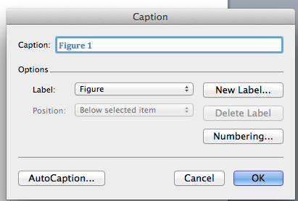

How to include chapter numbers in your captions
Including chapter numbers in your captions requires you to have automatically-generated chapter numbers in one of your heading styles. (In the Research Commons thesis template, that heading style is Heading 2.) If you have automatically-generated chapter numbers:
- In the Captions box, click on the “Numbering” button.
- Tick the box which says “Include chapter number”.
- In the drop-down menus, select the heading style which includes the chapter number, and the separator type you would like to use (e.g., hyphen, period, colon).
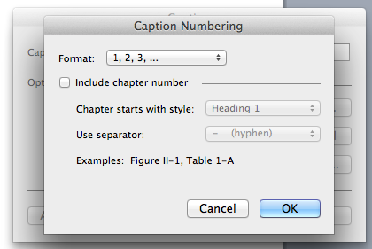

How to create a list of figures or tables
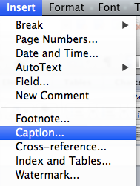
- Go to the Insert menu > Index and Tables.

- Go to the Table of Figures Tab.
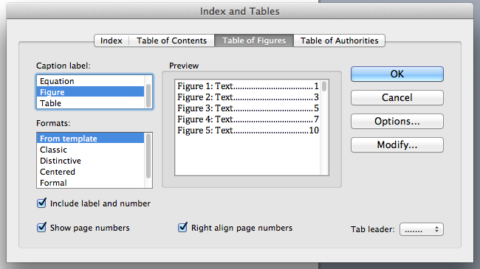
- Select the options you want and click “okay”. Note that the Faculty of Graduate and Postdoctoral Studies requires you to have your page numbers right aligned and a dot tab leader.

How to update a list of table or figures
- Place the cursor in the list you wish to update, go to the Document Elements Tab and press the “Update” button on the Table of Contents pane
- You’ll be given two options: “Update page numbers only” or “Update entire table.” Updating the entire table is more comprehensive, but it can take several minutes in a long document, so you may prefer to only update the page numbers if the content of your captions has not changed.

Miscellaneous Tips and Tricks

To check word count (e.g., in your Abstract), either
- Highlight selection and look at word box at the bottom of the page, OR
- Highlight selection and go to the Tools menu > Word Count

To make text white (e.g., in the heading of your Dedication), either
- Highlight the text, go to the Home tab, and select white from the drop down font color menu in the Font pane, OR
- Go to the Format menu > Font to open the font window. Select white from the “Font color” menu in the middle of the window

To fix line spacing in your body text, either
- Go to the paragraph pane on the Home tab. Click the line spacing button (third from the right on the bottom row) and select 2.0 for double spacing or click on “line spacing options” to open the paragraph formatting window, OR
- Go to the Format menu > Paragraph to open the Paragraph formatting box. Use the drop down menu to select line spacing

How to create and update cross references
- Go to Insert> Cross Reference
- Cross references should update when you open the print window (even if you don’t print). You can also force them to update by selecting all, pressing the Control button, clicking anywhere in the document, and selecting “update field” from the menu that appears

