Useful Tricks in Word

Outline View
- Use the buttons on far lower right of the window to toggle between view options
  - Far right is draft view, second from the right is outline view, fourth from the right is print view
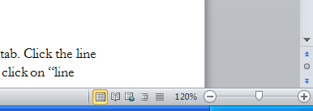

Navigation Pane
To make the sidebar Navigation pane appear, go to the View tab > Show > check the Navigation Pane box. Once you make the sidebar visible, you can switch between different viewing options (viewing by headings or by pages, or searching the text) using the three buttons at top of the pane.

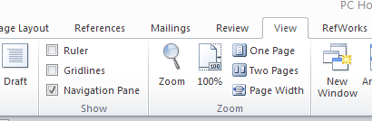

Showing Hidden Codes
To reveal codes which are usually hidden – such as paragraph markers, tabs, page breaks, and section breaks – click the Home tab> Paragraph > ¶ button in the top right corner of the Paragraph pane.

Page Layout and Numbering

To change your page numbers, either
Go to the Insert tab > Header & Footer > Page Number to open the drop-down menu. Click the “Format Page Numbers” button to open the “Page Number Format” window. Change the number format using the drop down menu at the top of the window.

OR

Double-click in the area around a page number to bring up the Header & Footer tab, and follow the instructions above to open the “Page Number Format” window.

To change your page numbers after a section break
Follow the instructions above to open the “Page Number Format” window. Click the “Continue from previous section” button if you want your numbers to continue consecutively. Click the “Start at” button if you wish to re-start your numbers, and use the drop-down menu to select which page number to start with.

How to put one page in landscape orientation
- Insert section breaks before and after the section you wish to put in landscape. Go to the Page Layout Tab and click on the Breaks button in the Page Setup pane to open the drop-down menu. Select Section Breaks > Next page. THEN,
- Go to the Page Layout Tab, click on the Orientation button in the Page Setup pane to open the drop-down menu and select “Landscape”

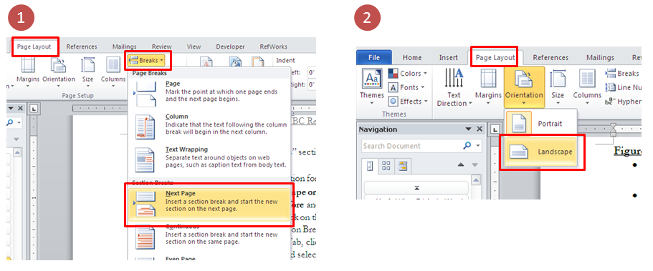

Chapters and Sections

How to apply heading styles
- Go to the Home tab and select the style you wish to use from the Styles pane
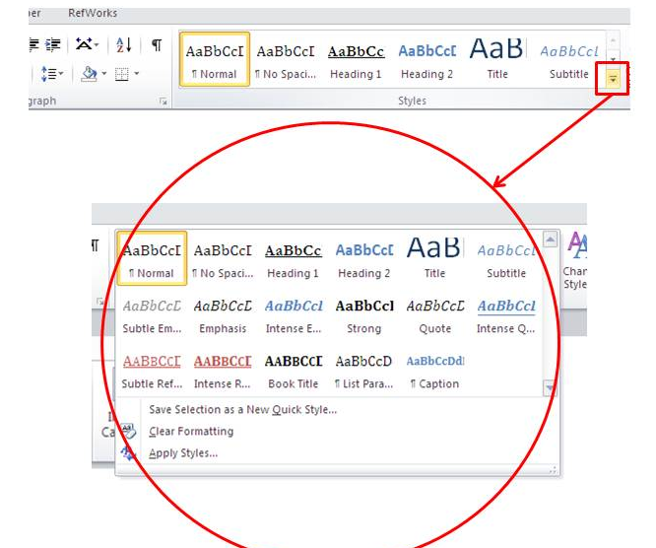

How to modify heading styles
- Go to the Home tab and right click on the style you wish to modify in the Styles pane

Notes on styles
- Only text which you’ve applied a Heading style to (i.e., one of Heading 1 through Heading 9) will appear in your Table of Contents.
- If there is material in your Table of Contents which is not supposed to be in your Table of Contents (e.g., body text below a heading), make sure that that material is in “Normal” style rather than one of the Heading styles.

Table of Contents

How to create a Table of Contents
- After you apply heading styles as necessary, go to the References tab, and click the “Table of Contents” button in the Table of Contents pane. Click “Insert Table of Contents” to open the Table of Contents formatting window. Select the options you want and click “OK”

To update a Table of Contents, either
- Click on the Table of Contents. Go to the References tab, click the Update Table button in the Table of Contents pane, OR
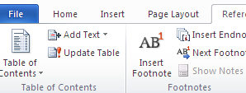

- Right-click on the Table of Contents, and select “Update Table” from the menu that appears
- You’ll be given two options: “Update page numbers only” or “Update entire table.” Updating the entire table is more comprehensive, but it can take several minutes in a long document, so you may prefer to only update the page numbers if the chapter and section headings have not changed.

Tables, Figures, and Other Objects

To make the heading row of a table repeat on subsequent pages, either
- Double click on the table to reveal the Table Tools Tabs. Select the Layout tab. Select the header row, and click the “Repeat Header Rows” button. OR,

- Right-click in the header row of the table, and select “Table Properties” from the menu that appears. Open the Row tab and select the “Repeat as header row at the top of each page” option

To insert captions, either
- Select the item you wish to caption. Go to the References tab > Captions pane > “Insert Caption” button, OR
- Place your cursor above or below the item you wish to caption. Go to the References tab > Captions pane > “Insert Caption” button

How to create a new caption label
- The default options for labels in Word are Equation, Figure and Table.
- If you need a different label (e.g., Map, Illustration, Image), click on the “New Label” button in the Captions box
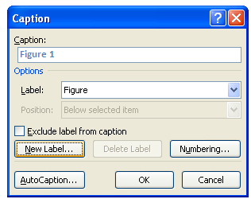

How to include chapter numbers in your captions
Including chapter numbers in your captions requires you to have automatically-generated chapter numbers in one of your heading styles. (In the Research Commons thesis template, that heading style is Heading 2.) If you have automatically-generated chapter numbers:
- In the Captions box, click on the “Numbering” button.
- Tick the box which says “Include chapter number”.
- In the drop-down menus, select the heading style which includes the chapter number, and the separator type you would like to use (e.g., hyphen, period, colon).
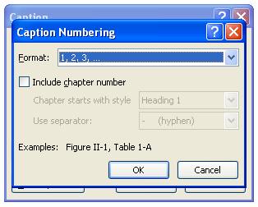

Creating Lists of Tables and Figures
- How to create a list of figures or tables
  - Go to the References tab > Captions pane > “Insert Table of Figures” button. Select the options you want and click “OK”
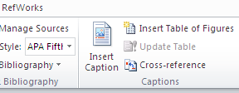

  - Select the options you want and click “OK”. Note that the Faculty of Graduate and Postdoctoral Studies requires you to have your page numbers right aligned and a dot tab leader.
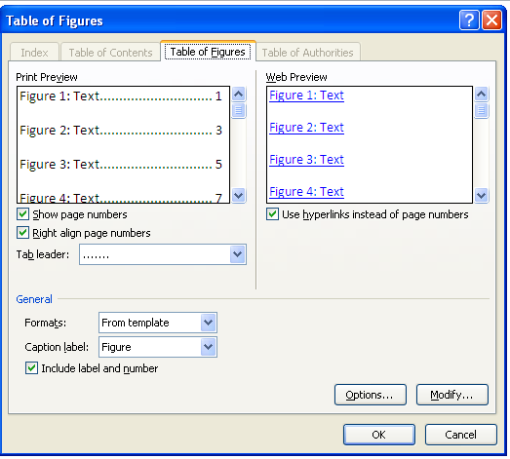

- To update a list of tables or figures, either
  - Click on the list you want to update. Go to the References tab and press the “Update Table” button in the Captions pane, OR
  - Right-click on the list you want to update, and select “Update Table” from the menu that appears

Miscellaneous Tips and Tricks

To check word count (e.g., in your Abstract), either
- Highlight selection and look at word box at the bottom left-hand corner of the page, OR
- Highlight selection and go to the Review tab > Proofing > Word Count

To make text white (e.g., in the heading of your Dedication)
- Highlight the text. Go to the Home tab, and select white from the drop down font color menu (the capital “A” with a line underneath it) in the Font pane

To fix line spacing in your body text, either
- Go to the Paragraph pane on the Home tab. Click the line spacing button (third from the right on the bottom row) and select 1.5 or 2.0 , or click on “line spacing options” to open the paragraph formatting window, OR
- Go to the Paragraph pane on the Home tab. Click on the arrow on the bottom right corner of the pane to open the Paragraph formatting box. Use the drop down menu to select line spacing

How to create and update cross references
- Go to the References Tab and click the Cross Reference button in the Captions pane
- Cross references should update when you open the print window (even if you don’t print).

