How to Add Citation Add-ins to Microsoft Word

Part 1: Add the App Catalog to the Trust Center
- In Microsoft Word, click on the File tab, then click on Options.
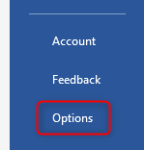
- Click on Trust Center.
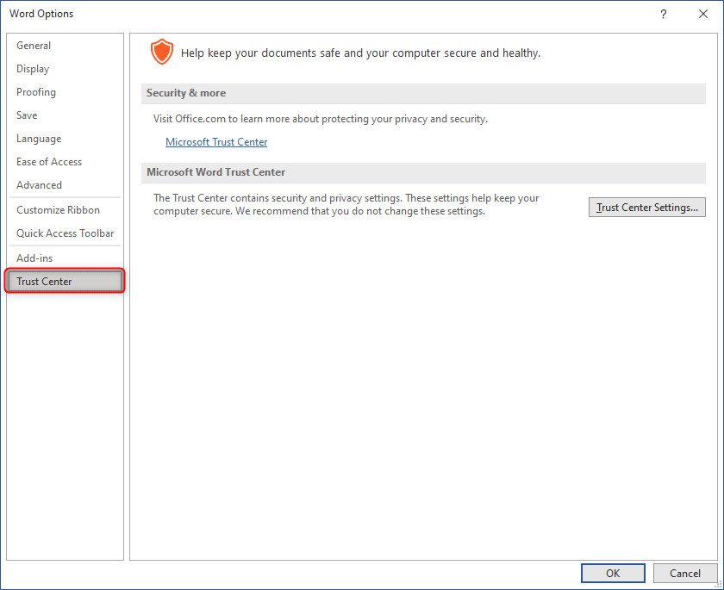
- Click on the Trust Center Settings button.
- Click on Trusted Add-in Catalogs.
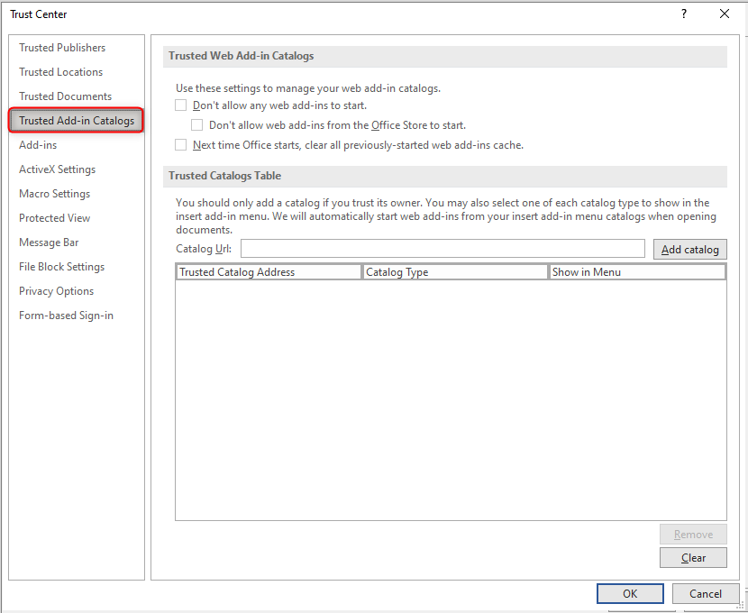
- For Catalog Url, type in:
https://ubcca.sharepoint.com/sites/appcatalogue

- Click on the Add catalog button.
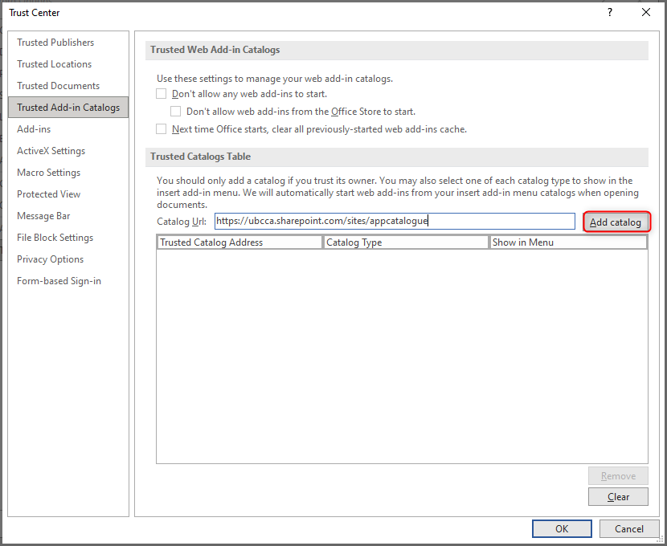
- Place a checkmark to select Show in Menu.
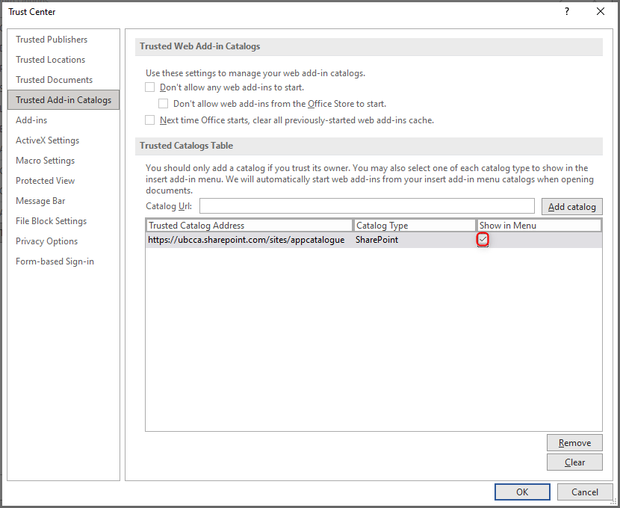
- Click OK to save your changes.
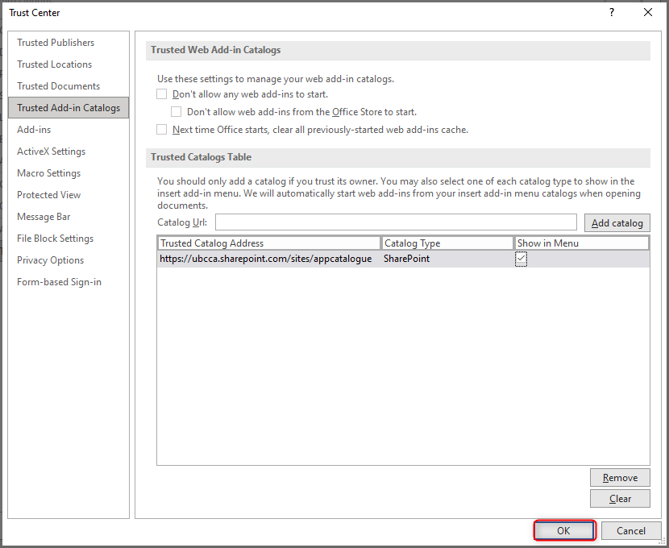
- When prompted, click OK.
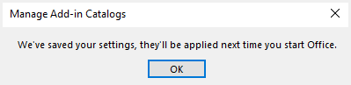
- Click OK.
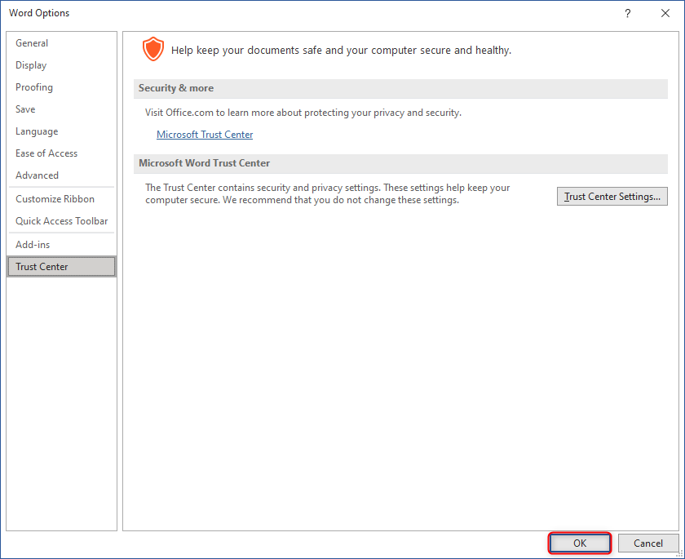
- Close and re-open Microsoft Word.

Part 2: Add the Citation Add-in
- Click on the Insert tab.
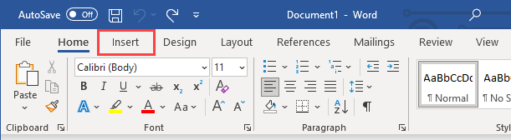
- Click on My Add-ins.
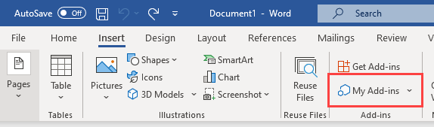
- Click on My Organization.
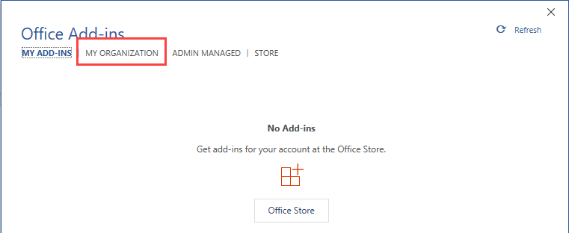
- Click on the desired add-in and click OK.
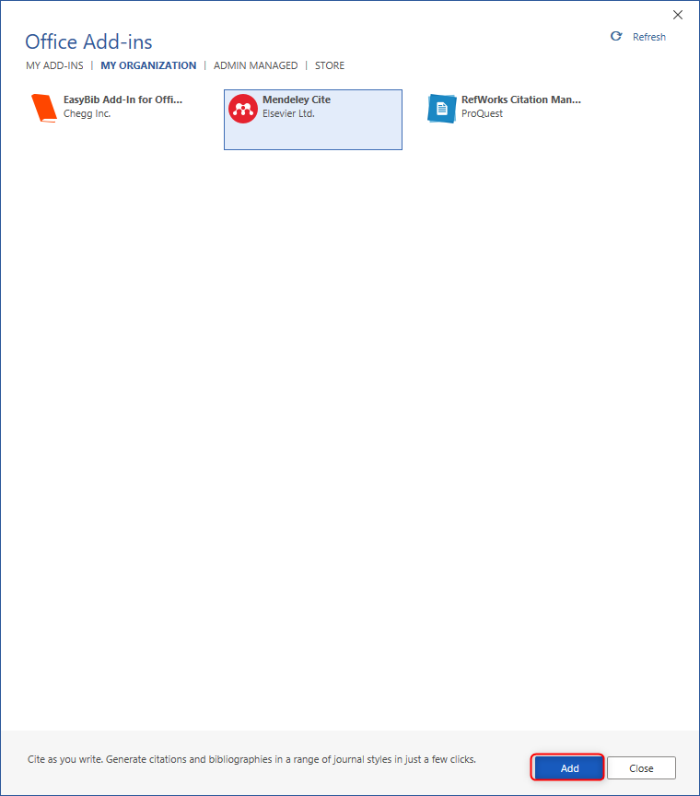
- The add-in will appear and be ready to use.
